**PORTFOLIO**

COMPUTER SCIENCE AND ENGINEERING

Submitted by:

Name: Ashish Repswal

Registration number: 12406445

Roll No.: RK24CTA05

Section: K24CT

# Submitted to : Dr. Joshva Raj G



**LOVELY PROFESSIONAL UNIVERSITY**

# DECLARATION

I, Ashish Repswal, a student of Bachelor of Technology under CSE discipline at Lovely Professional University, Punjab, hereby declare that all the information furnished in this project report is based on my own work and is genuine

ASHISH REPSWAL

Registrartion Number: 12406445

|  |  |  |
| --- | --- | --- |
| Platforms for profile creation | Link to student profile | Screenshot |
| Figma | Since internal profile doesn’t work, so I am a6aching project link    Project1:  https://www.figma.com/files/team/1432723912848022282/recents-and-sharing/recently-viewed?fuid=1432723910713809291 | **1** |
| Quora | https://www.quora.com/profile/Ashish-Repswal-3 | **2** |
| Stack overflow | https://stackoverflow.com/users/28026118/ashish-repswal | **3** |
| Hacker Rank | https://www.hackerrank.com/profile/ashishrepswal23 | **4** |
| Hacker Earth | https://www.hackerearth.com/@ashishrepswal23/ | **5** |
| Geeks for  Geeks | https://www.geeksforgeeks.org/user/ashishreos0z/ | **6** |
| LinkedIn | https://www.linkedin.com/in/ashish-repswal-82b256320/ | **7** |
| Github | https://github.com/ashishrepswal | **8** |
| CV | https://drive.google.com/file/d/14yc5HaaF7EpZ_upDQRovFipW7wBtAFsy/view?usp=drivesdk | **9** |
| MOOCS done | 1. | **10** |

# 1.FIGMA

**Profile: Figma internal profile with project**

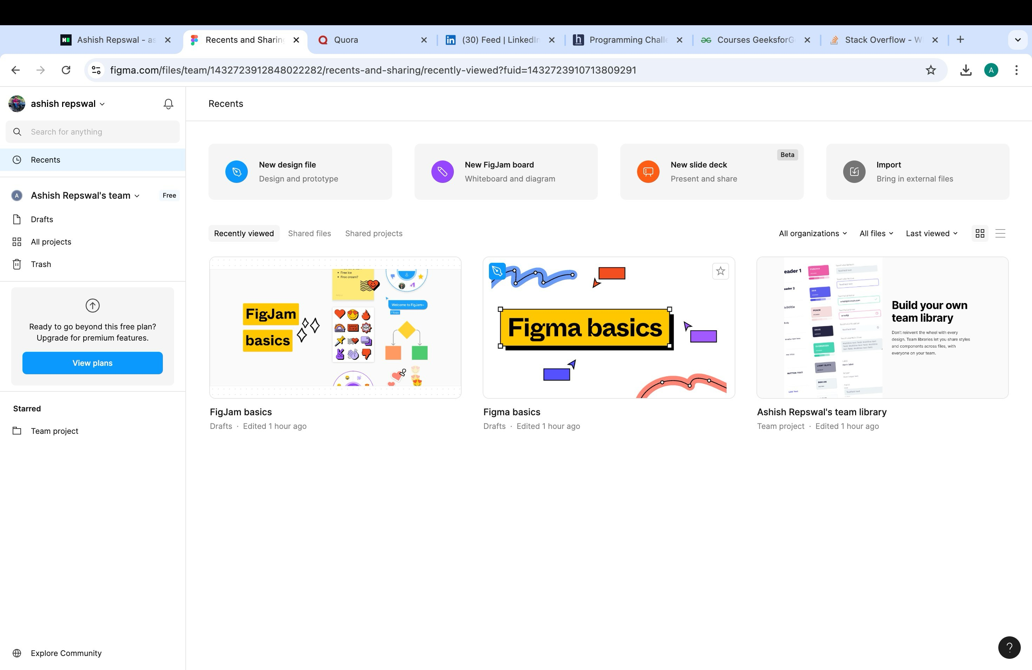

# 2.QUORA

**PROFILE AND ACCOMPLISHMENT:**

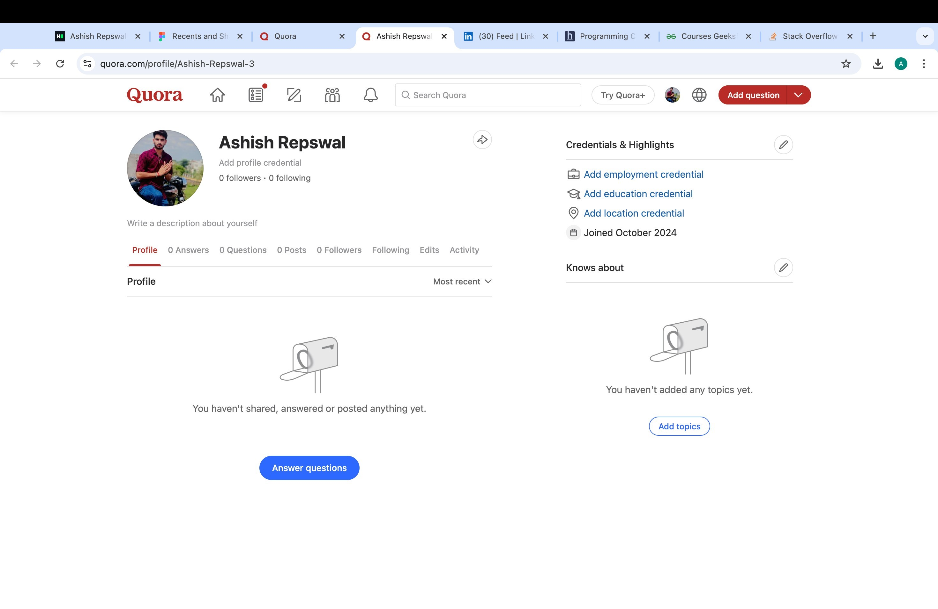

# 3.STACKOVERFLOW

**PROFILE:**

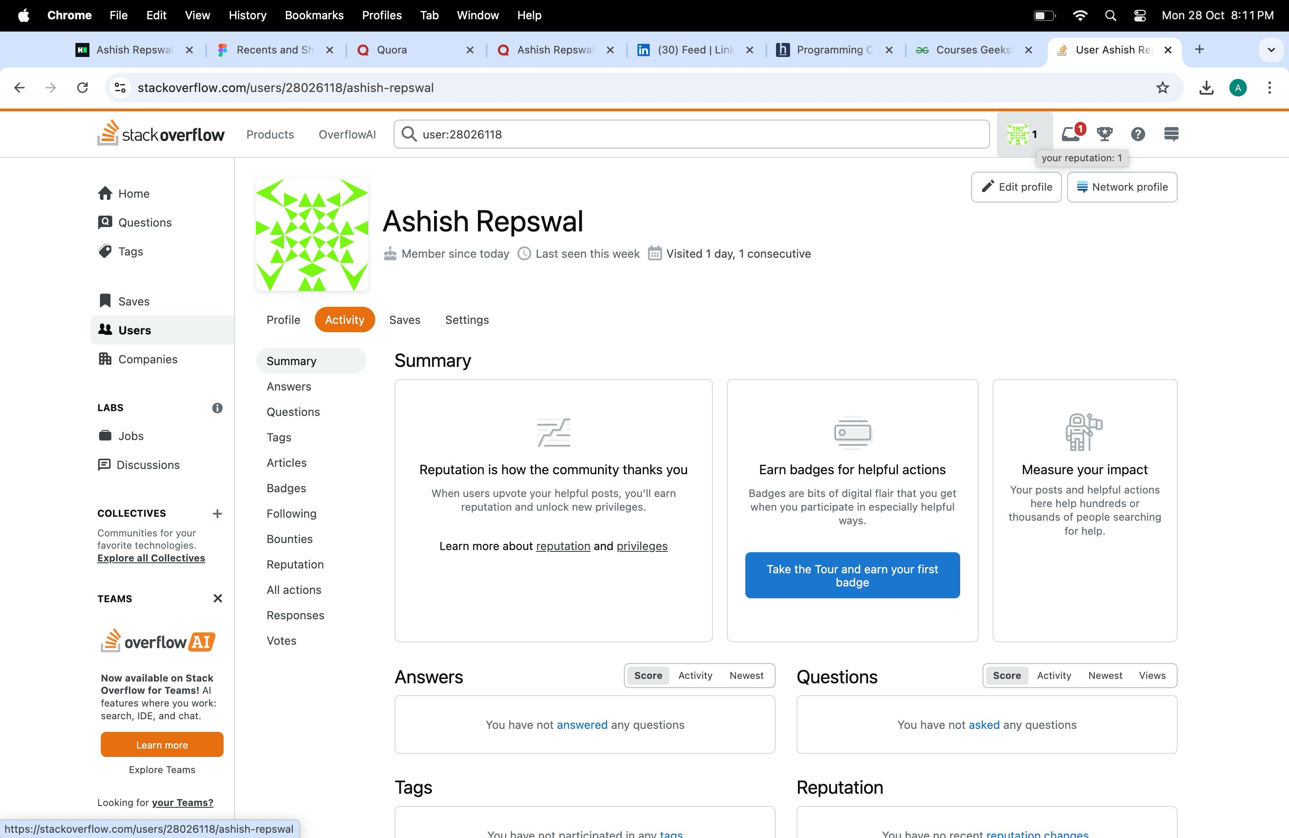

# 4.HACKER RANK

**Profile:**

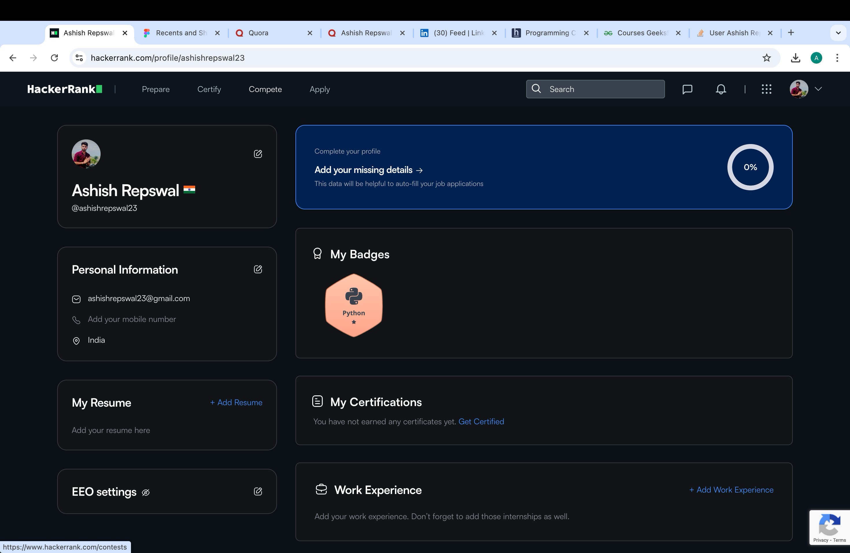

# 5.HACKER EARTH

**Profile:**

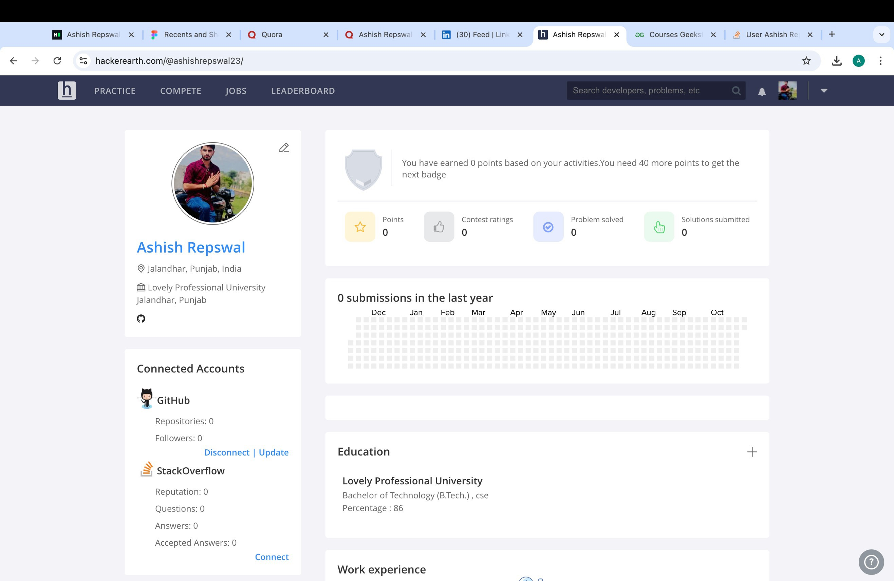**:**

# 6.GEEKS FOR GEEKS

**Profile:**

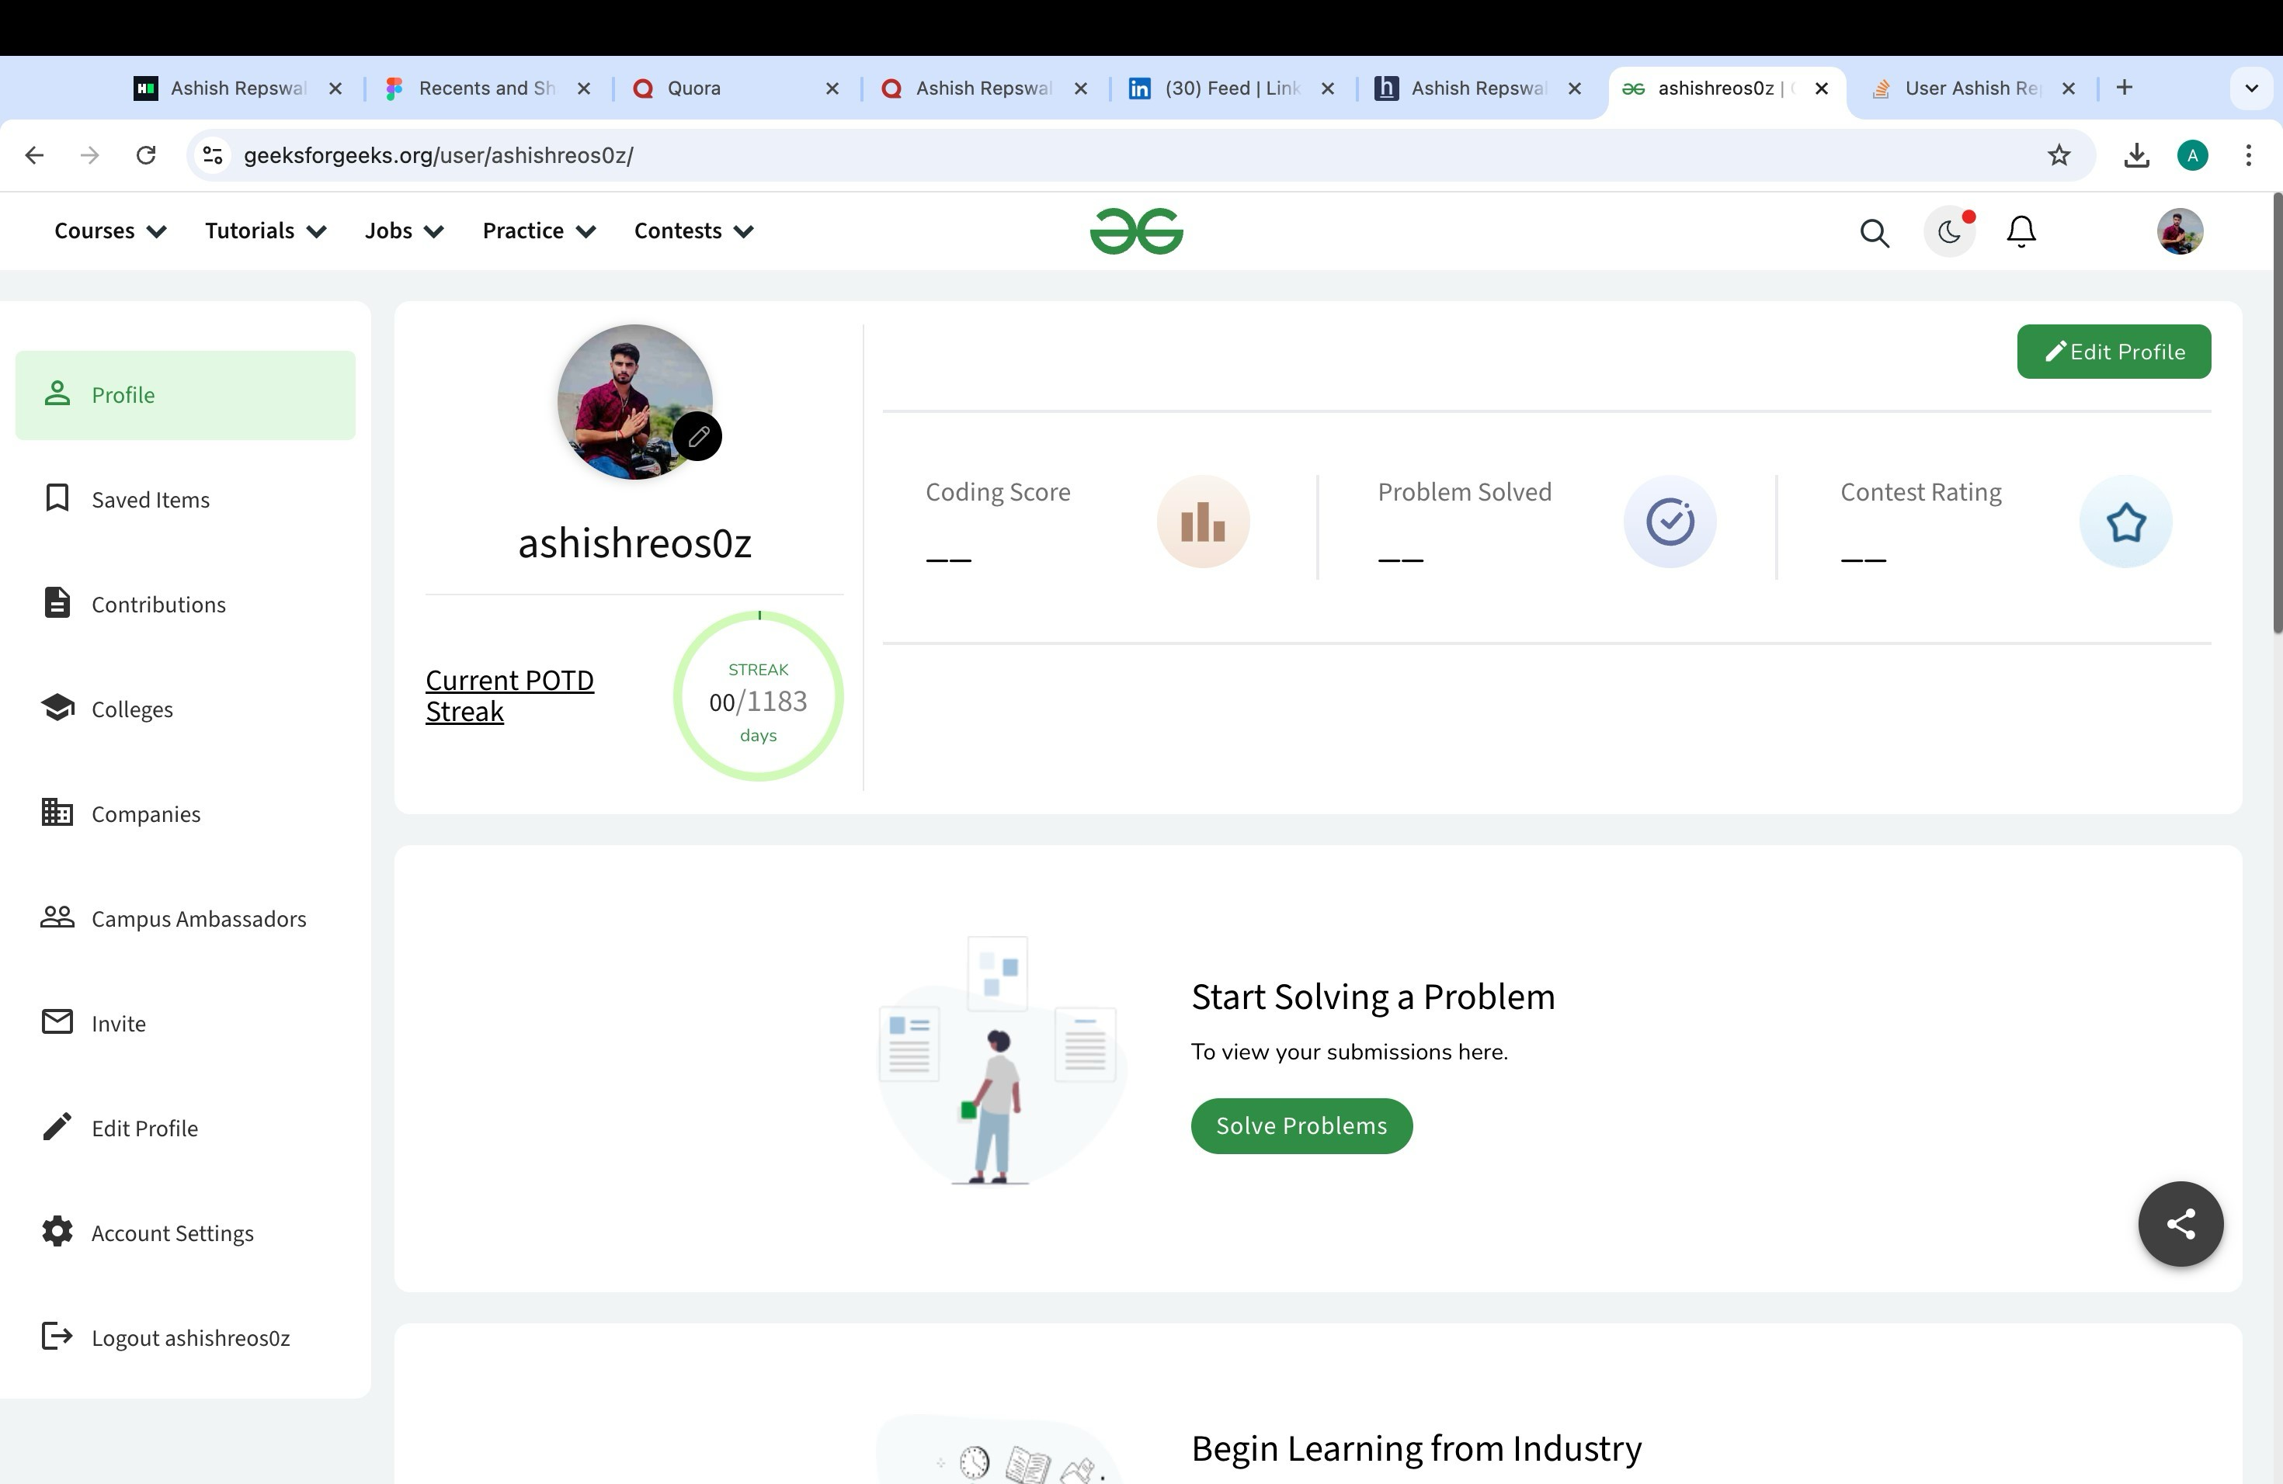

## 7. LinkedIn

**Profile:**

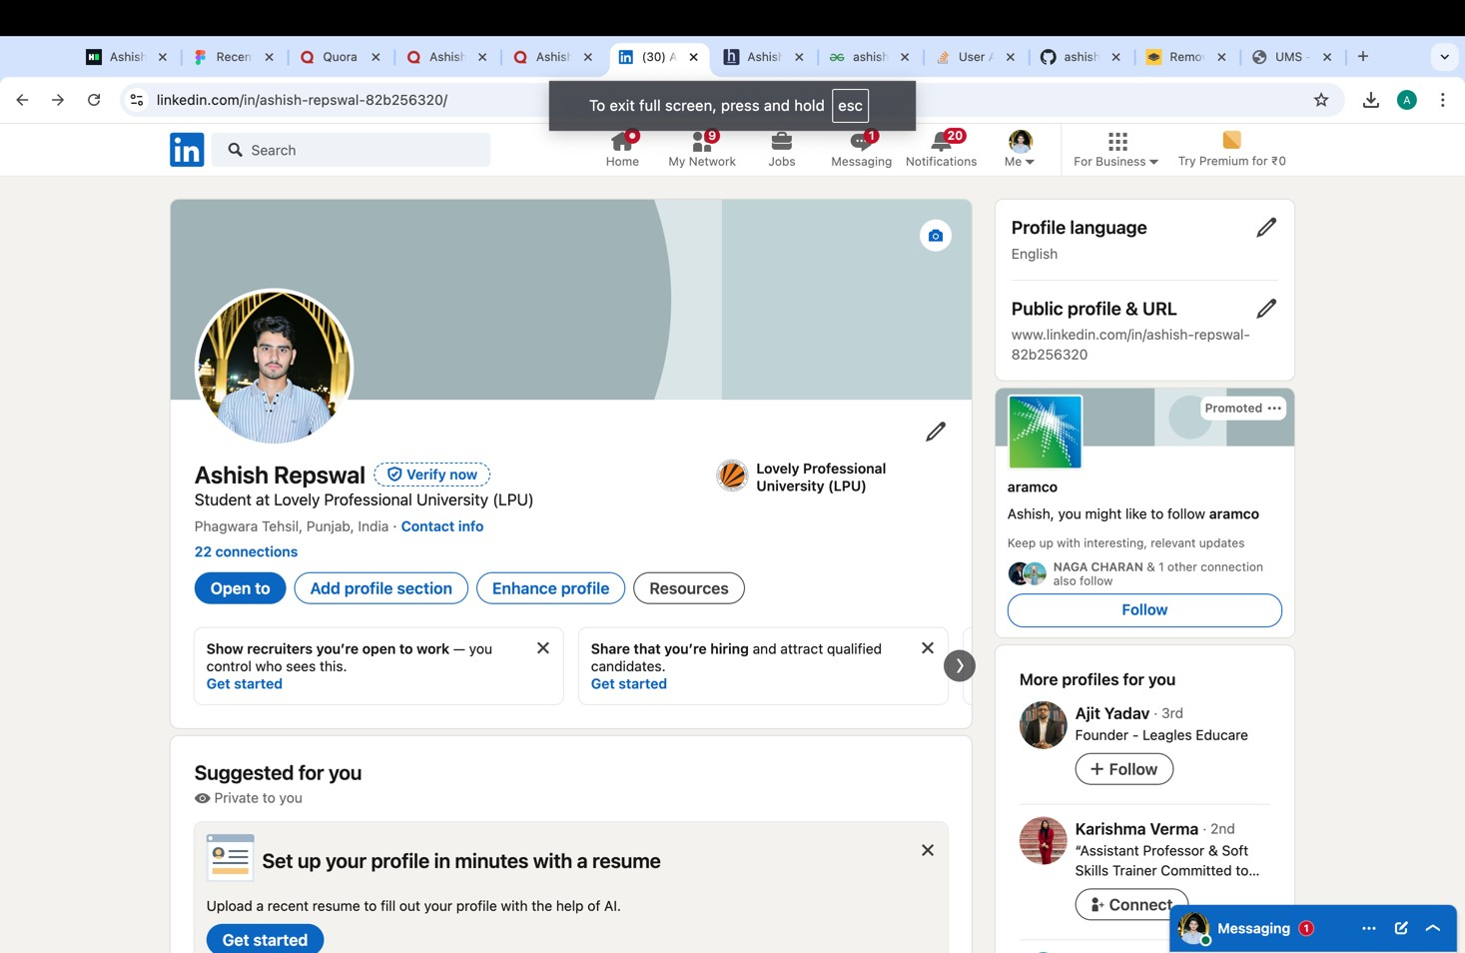

## 8. GITHUB

**Profile:**

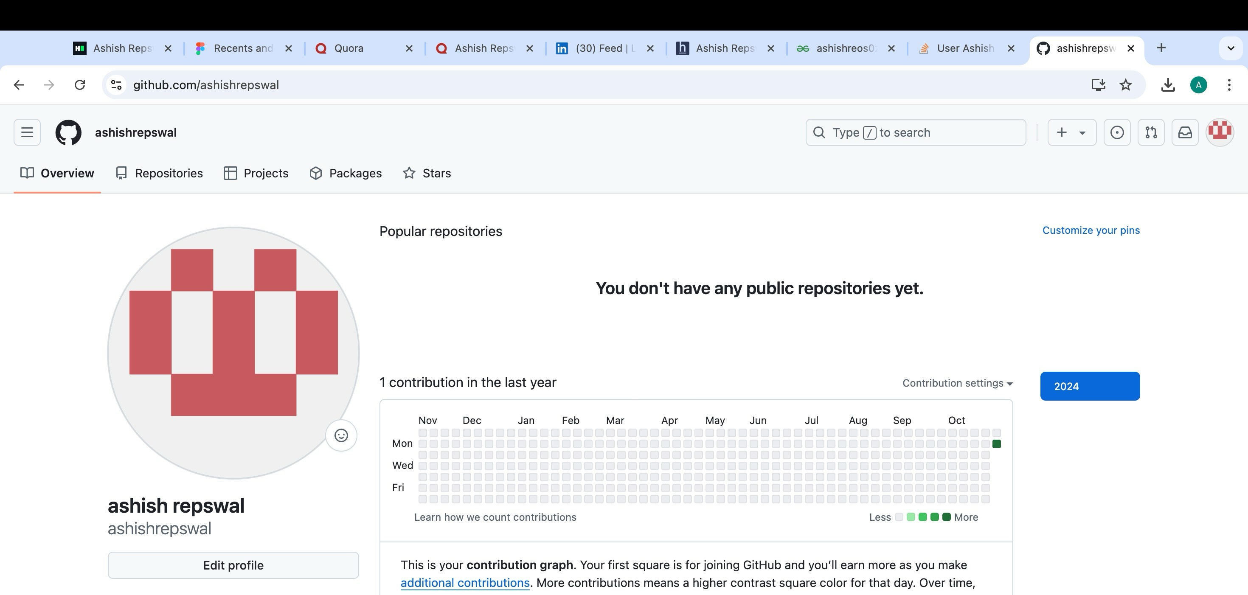

# 9.CV



# 10.MOOCS completed

